# Back to Pre-War Levels — What's Next? Air Cargo in H1 2026 and the H2 Outlook

*Written based on analysis by Samsung SDS Logistics Experts (Logistics MI Group).*

While ocean freight was rattled by front-loading and geopolitical risk, air cargo told a slightly different story in H1 2026. Demand recovered quickly to pre-war levels, but supply couldn't keep pace — and that gap kept rates elevated. Here's the H1 trend, followed by the H2 outlook.

## H1 Trend: Demand — Rapid Recovery to Pre-War Levels

H1 demand rose 4.4% YoY, a rapid recovery to pre-war levels that put demand ahead of supply.

Asia was the key growth driver, growing 5.6% YoY — Asia-Europe volume growth alone accounted for over 75% of total Asia-route growth. The Middle East told the opposite story, falling 15.2% YoY amid the direct impact of the war.

## H1 Trend: Supply — Gradual Recovery, Slightly Behind Demand

H1 supply rose 1.9% YoY, a gradual recovery after the ME shock, but slightly below demand growth. Recent short-term recovery has been driven mainly by belly capacity increases.

Breaking it down by aircraft type: freighter capacity (41% of the total) grew 6.3% YoY, the fastest-growing segment. Passenger belly capacity (also 41%) fell 2.8%, while express capacity (19%) grew 2.9%. Total capacity was up 1.8% YoY overall.

This freighter capacity growth was led by Northeast Asia-North America supply growth — Pacific freighter capacity rose 16% YoY, with China up 38%, Taiwan up 12%, and Korea up 11%. Airlines are clearly reallocating cargo capacity toward high-yield Pacific routes.

## H1 Trend: Rates — A 3-Year High After the ME War

H1 rates rose 12.1% versus the previous year's average, hitting a 3-year high amid the ME supply shock and remaining elevated.

Rate gains widened most on two key lanes: Asia-North America, where chip demand is concentrated, and Asia-Europe, given its high exposure to Middle East transit.

Following the timeline: rates surged at the U.S.-Iran war outbreak, driven by a peak supply shock and jet fuel price spike. Pre-holiday shipping ahead of May added further pressure. A U.S.-Iran ceasefire deal followed, but front-loading ahead of EU low-value parcel duties kept rates elevated through the rest of H1.

## H2 Outlook: Demand — Entering a Low-Growth Phase, But Core Lanes Stay Tight

2H demand growth is expected to slow to 2–3%, down from 4% in 2025, as air cargo enters a moderate low-growth phase. This reflects a normalization after the 2024 e-commerce surge.

But the growth engine itself is shifting — from e-commerce to AI and chips. China-origin e-commerce sales fell 11% YoY (US -33%, EU -6%), and the traditional e-commerce peak in Q3-Q4 is expected to weaken. Filling that gap: global chip sales rose 106% YoY, Asia-North America chip shipments rose 22%, and Asia-North America AI/high-tech cargo volume rose 86% YoY — leading overall growth.

The result is that demand growth is concentrated on select high-demand lanes rather than spread evenly across the market. Asia-North America and Asia-Europe dynamic load factors are running at 87–90%, keeping supply-demand tight on those routes. Volume growth from electronics and chip hubs — Taiwan, China, Malaysia — is expected to widen transpacific growth, led by Northeast Asia-North America lanes.

## H2 Outlook: Supply — Aircraft Just Aren't Arriving Fast Enough

Supply faces a structural constraint. The gap between new orders and deliveries keeps widening: January-May 2026 new orders totaled 1,139 aircraft (Airbus 815, Boeing 324), while new deliveries totaled only 512. Delivery speed improved 11% YoY, but the order-delivery gap continues to widen, and it would take roughly 12 years to clear the current backlog.

As of May 2026, the backlog surpassed 18,100 units — about 60% of the total active fleet. Parts and engine delays, along with labor shortages, continue to slow output and build the backlog further.

This delivery bottleneck casts a shadow over freighter supply specifically. Retirement of aging aircraft has been delayed, pushing the average fleet age to a record 15.2 years. With older freighter production ending and new deliveries also delayed, freighter supply is likely to face growing pressure — a structural constraint on air cargo capacity over the mid to long term.

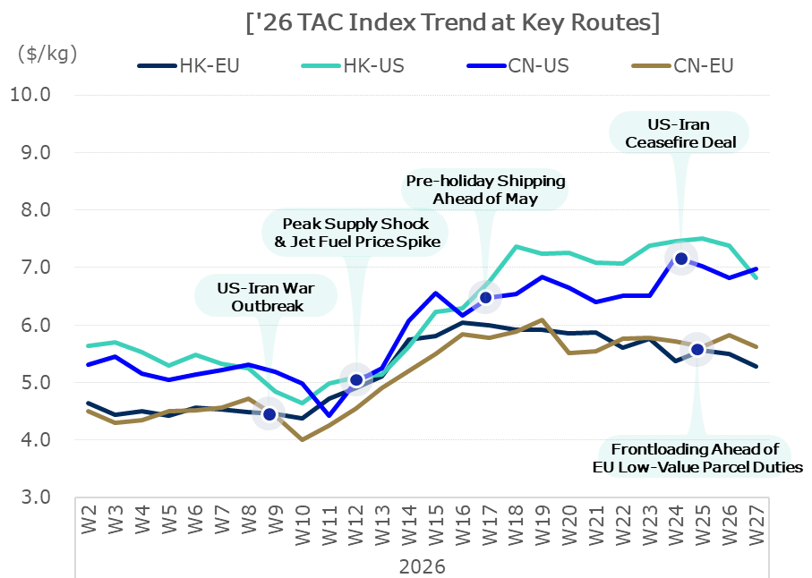

## H2 Outlook: Rates — Down in Q3, Up in Q4

H1 saw weak demand in Q1 on a slowdown, then a supply/oil shock from the ME war in Q2 that sent rates surging across all routes — a trend that has persisted. In H2, Q3 and Q4 are expected to move in opposite directions.

**Q3** favors downside factors. The oil and jet fuel surge is expected to normalize, easing costs and airlines' operating burden, while supply on long-distance routes expands alongside a faster summer passenger recovery. E-commerce growth is also expected to slow, compounded by the EU's low-value parcel duties. Following June's China front-loading, e-commerce volume is expected to run slightly weaker YoY. One wildcard: pre-launch shipments ahead of new mobile/PC releases could drive seasonal demand from Southeast Asia and India between August and October.

**Q4** favors upside factors. Rising AI investment keeps lifting data center and infrastructure demand, with HBM, AI servers, and data center equipment expected to drive air cargo demand. Layered on top of that is the year-end peak season — retail peak volume and year-end restocking are expected to absorb capacity, and space competition on Asia-origin long-haul routes could push rates up in the short term.

## The Bottom Line

Air cargo in 2026 follows an arc of its own: H1 saw rates hit a 3-year high on the ME war's supply shock, and H2 is expected to catch its breath in Q3 before rising again in Q4. Underneath it all is a shift in the demand engine — AI and chip cargo filling the space e-commerce is leaving behind — combined with a structural supply constraint from delayed aircraft deliveries.

The specific data behind this outlook — how fast jet fuel prices normalize by quarter, how AI cargo is growing lane by lane, and how fuel surcharges are being adjusted in stages — is covered with full figures in the complete report.

**This summary is drawn from the [H1 2026 Logistics Market Review & H2 Outlook] — see the full report for the complete picture →**

